**Performance Monitoring and Analysis with LoadRunner Case Study**

**Creating new solution and script**

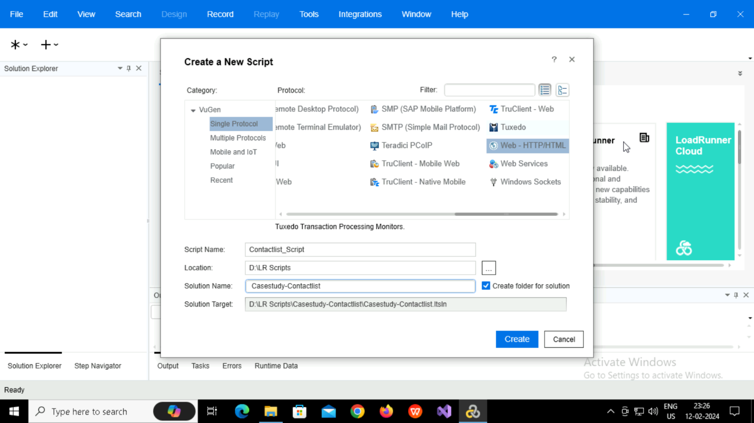

**Created Solution with name Casestudy-Contactlist and Script with Contactlist_Script**

**Recording the script**

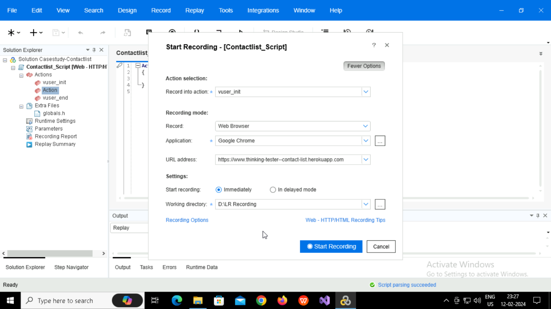

**Mapping and Flitering**

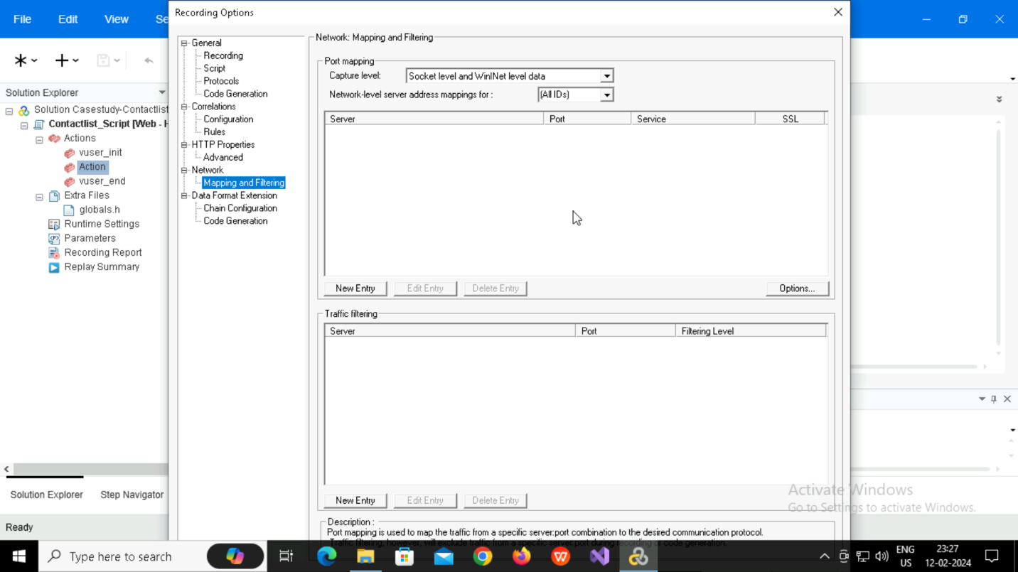

**Selecting HTTP/HTML Level**

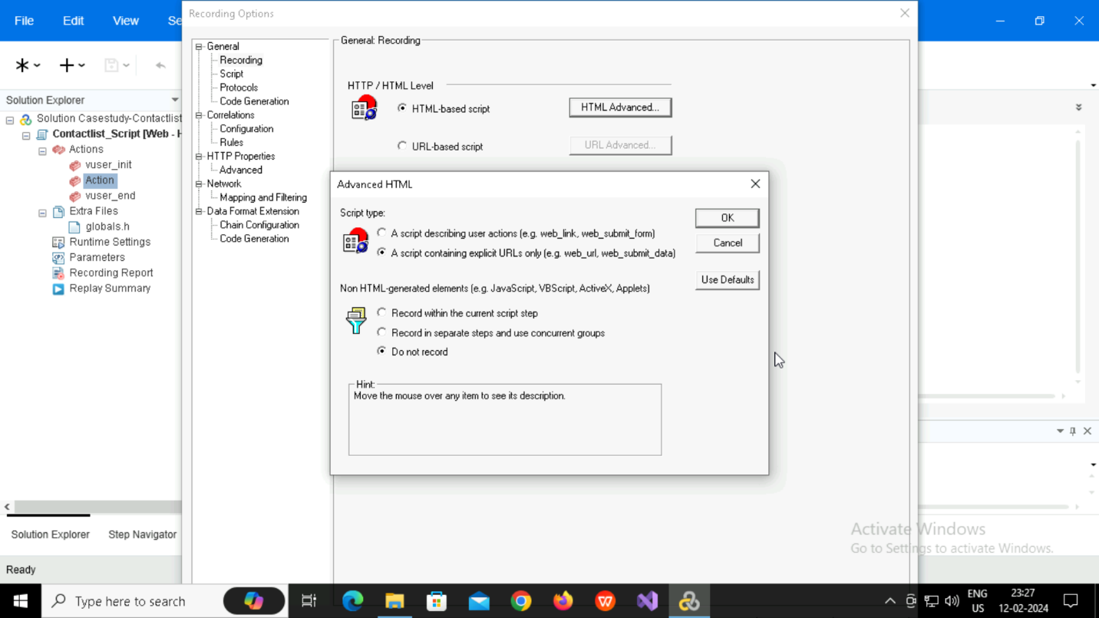

**Parameterization**

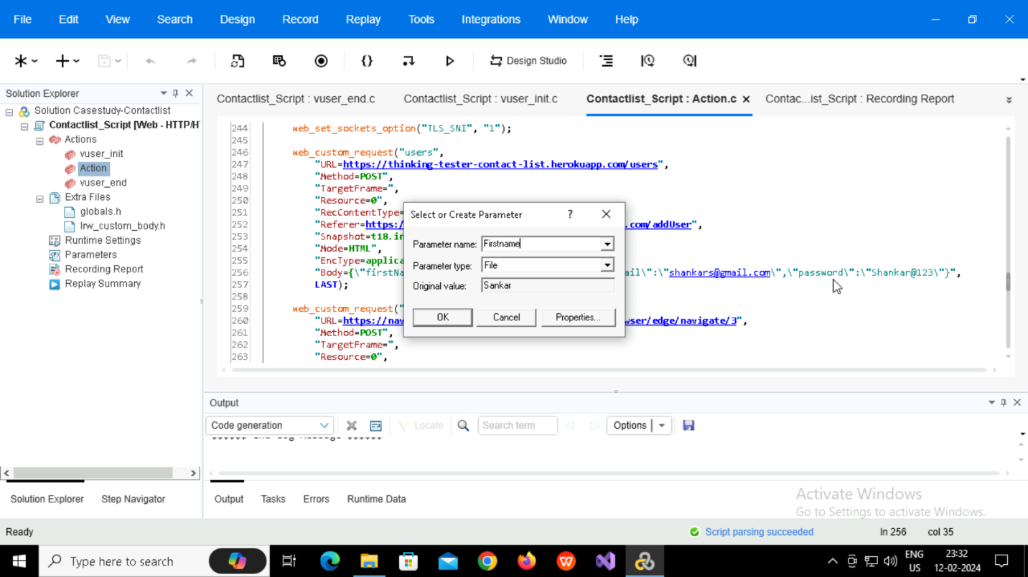

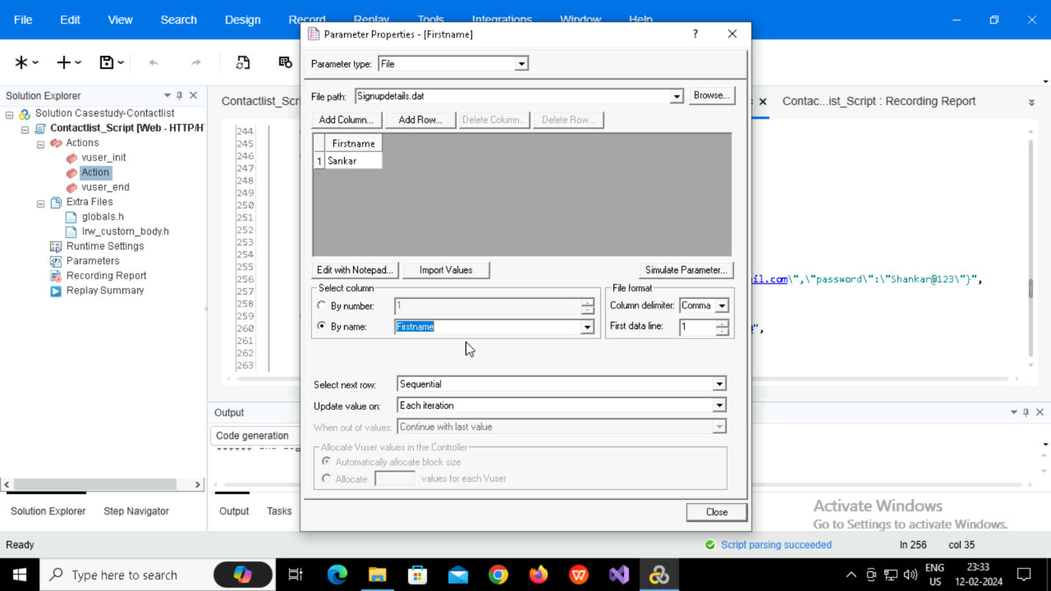

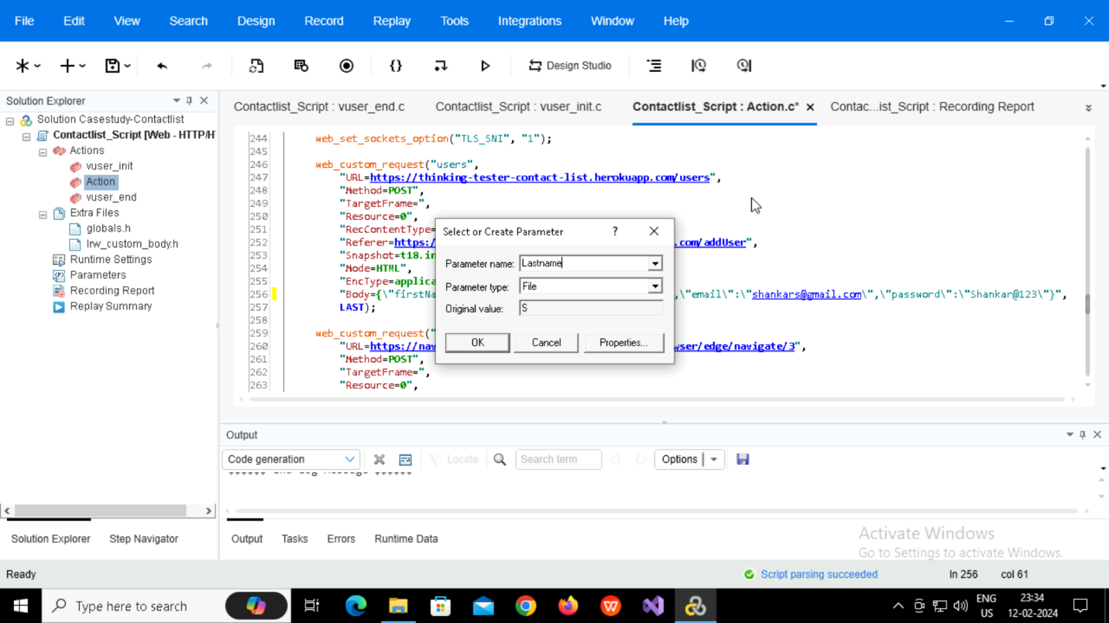

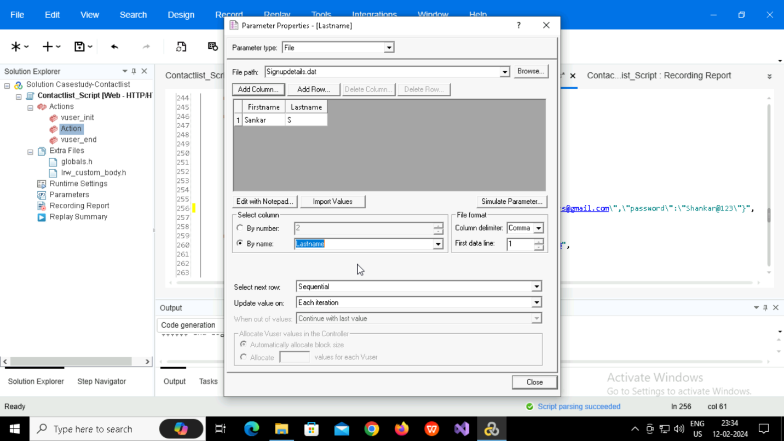

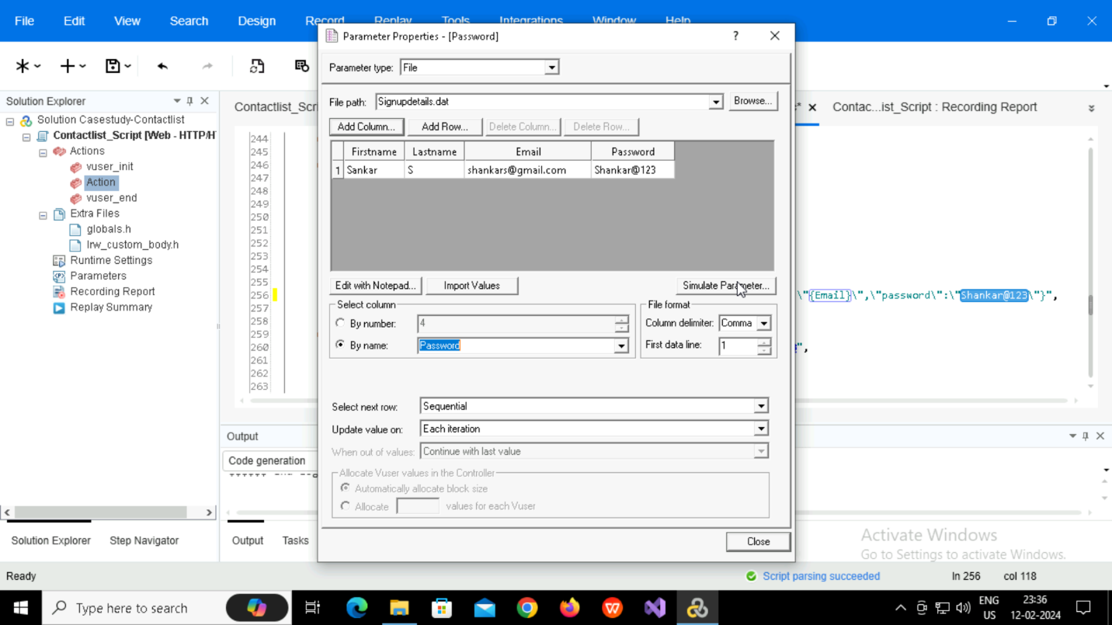

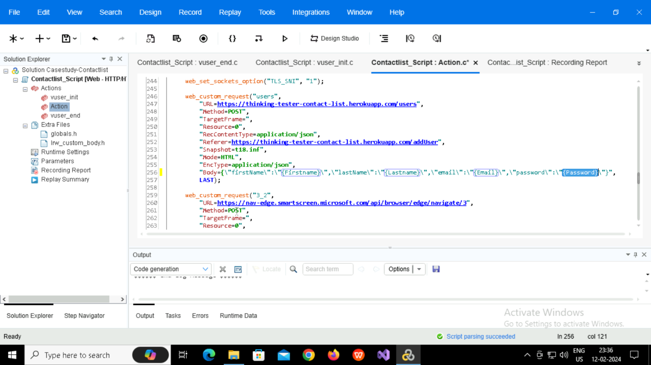

**Recorded and Replayed**

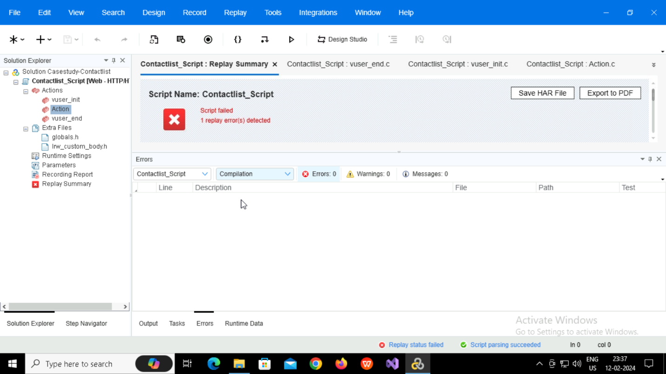

**Code Generation**

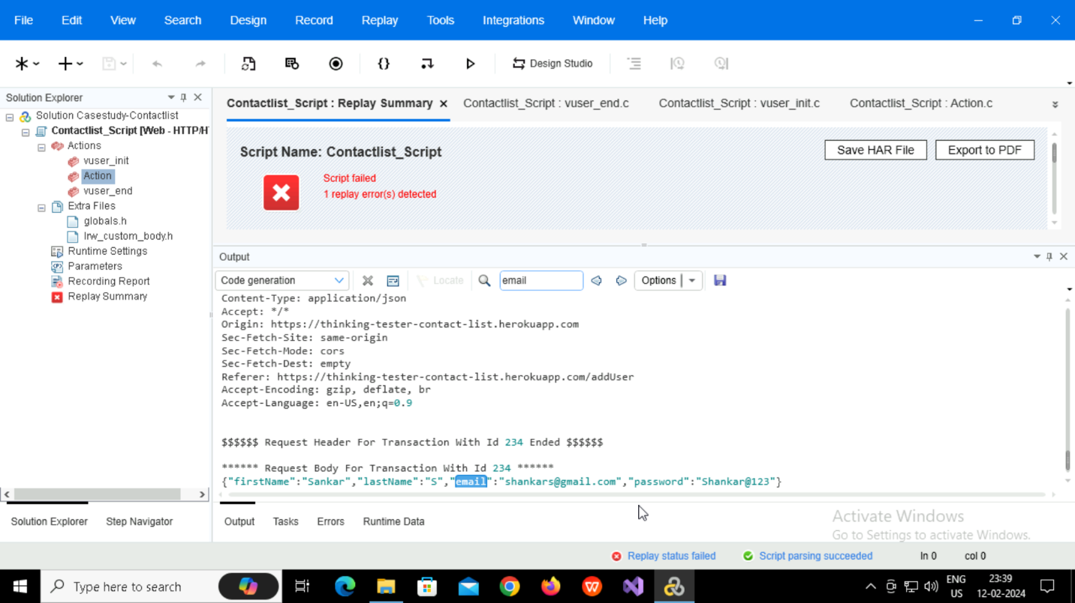

**Controller**

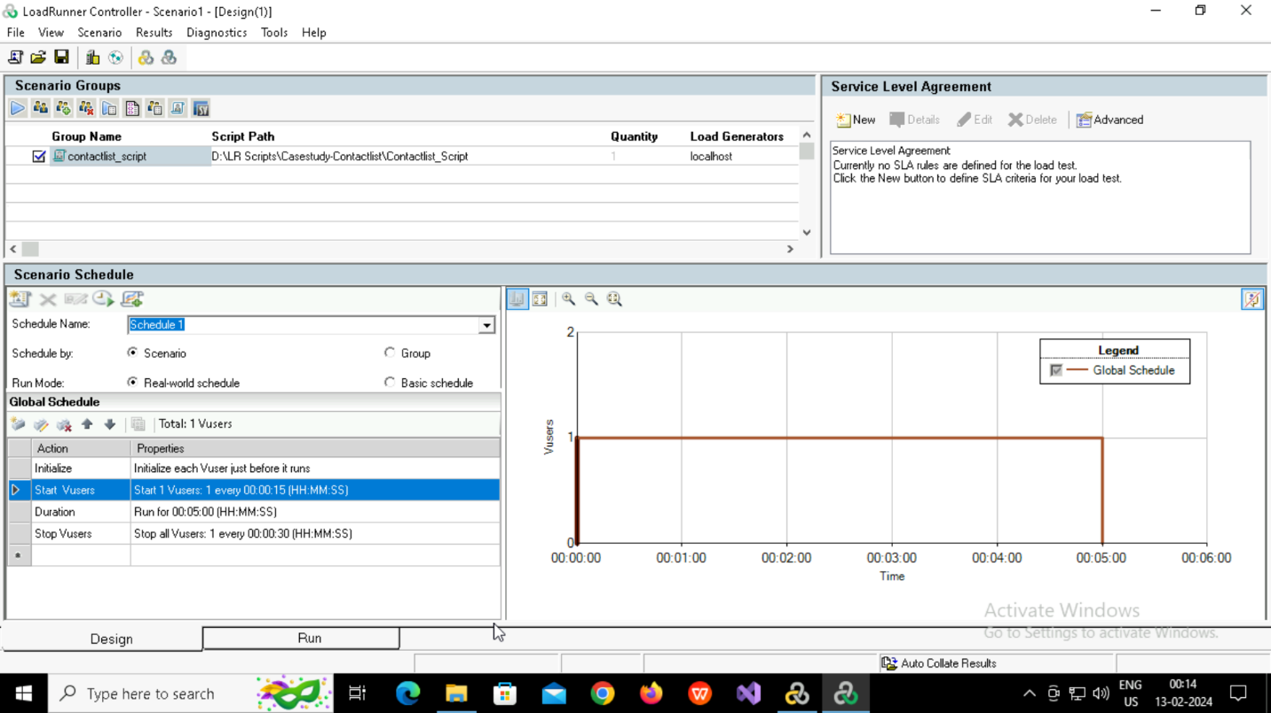

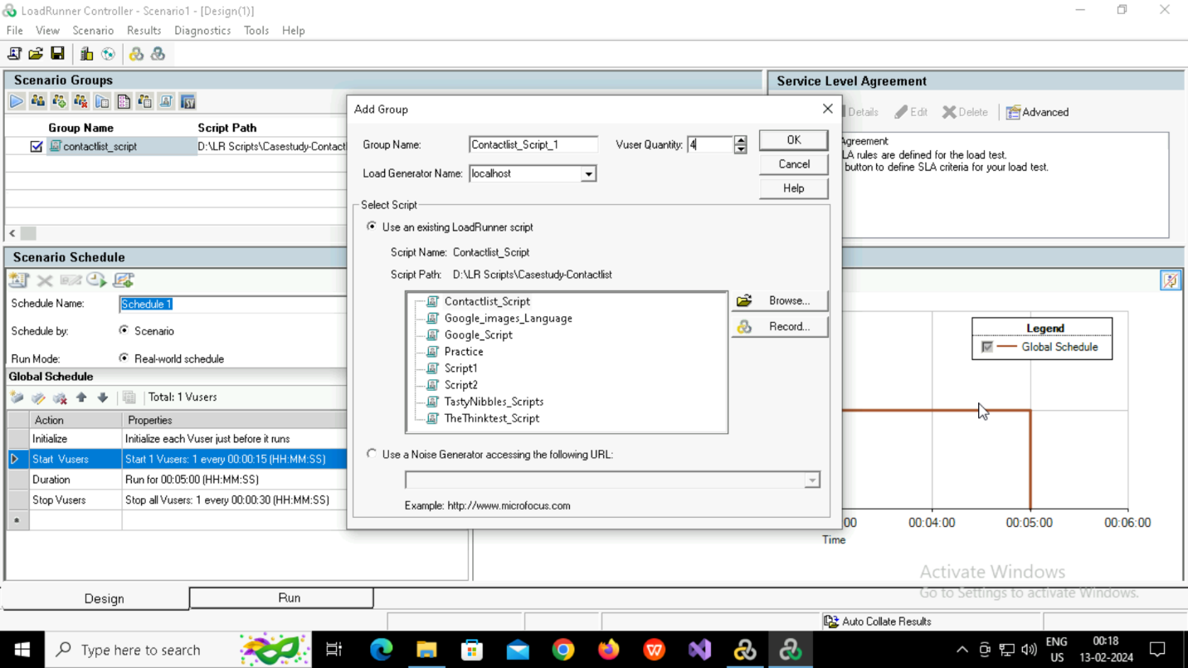

**Graphs in Controller**

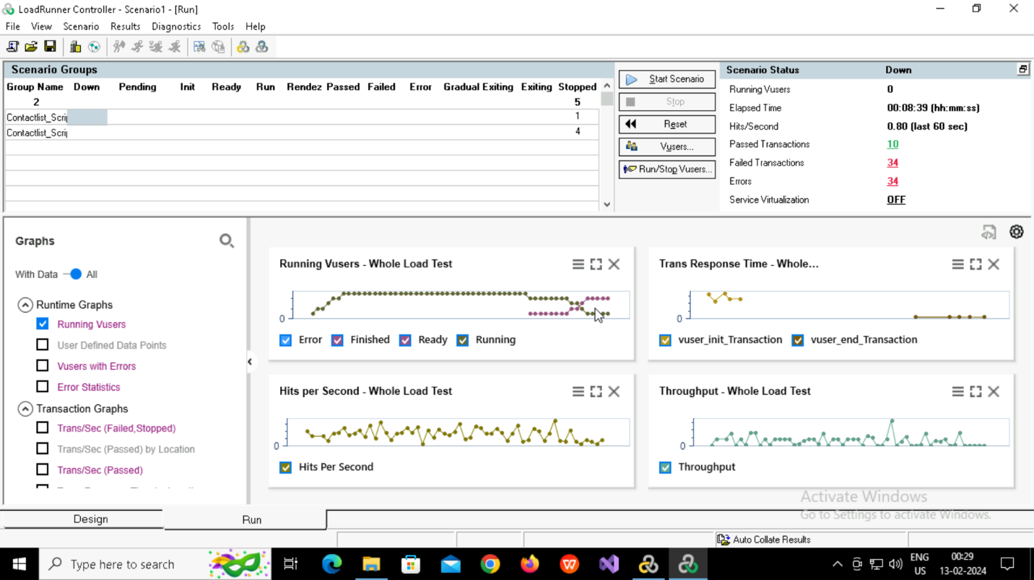

**Graphs in Analysis**

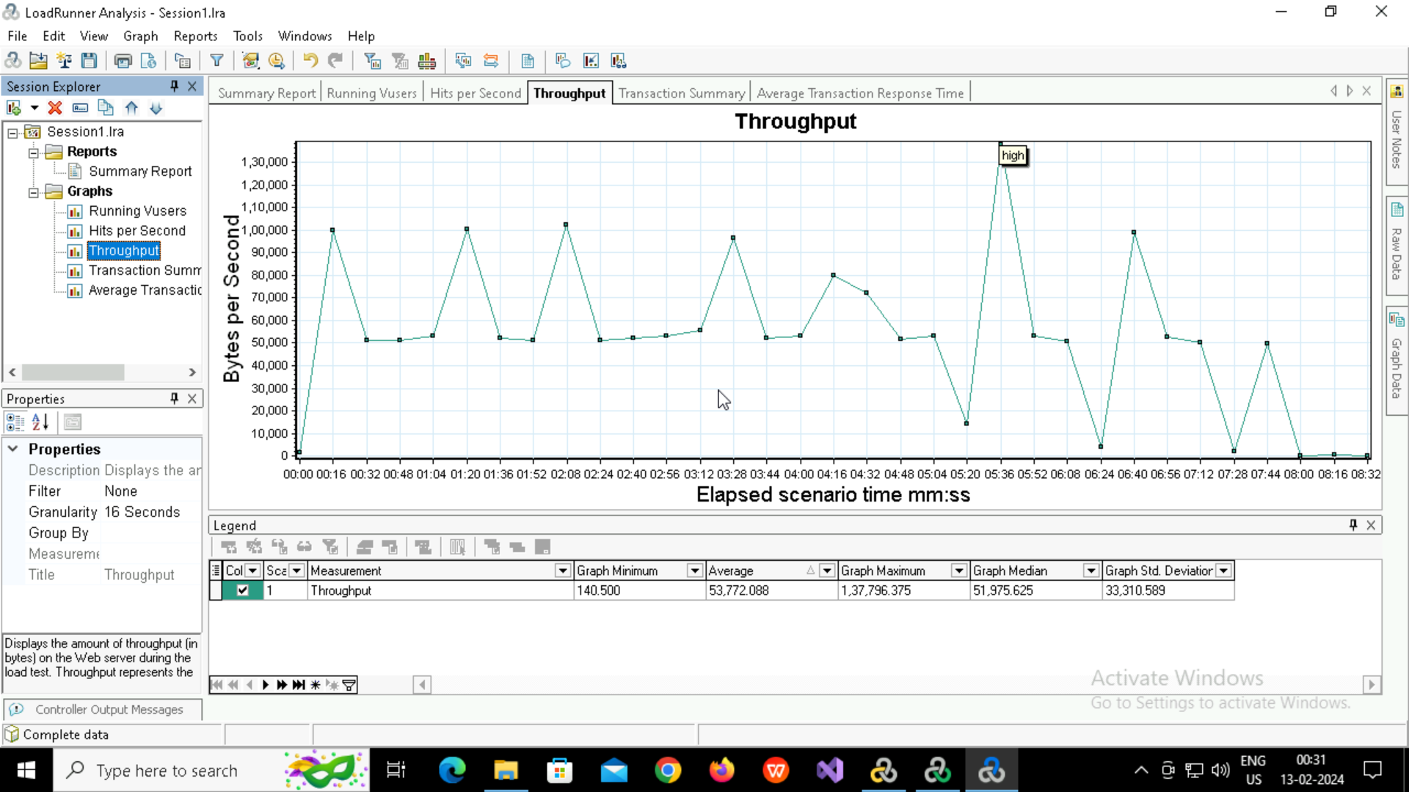

**HTML report generated**

